Catalogued Threatened Species:

Who and where are they?

Seth Carlyon, Gaby Garcia, Graham Jaeger, Kyle Murphy, Timothy Salazar

Recent decades have seen marked declines in global biodiversity. However the true extent of the issue is not fully known as estimates are only as good as the data they are made on. The IUCN is an international nonprofit that attempts to organize and catalog the global biota, assessing each species along a scale of degree of “threatened status”. We set out to understand what biases this dataset might have, using an amalgamation of sources.

IUCN Global versus Regional datasets

The IUCN database is comprised of assessments on 153,732 species. We collected a pseudo-random subset of 10,000 species to compare against an equal sized subset of the European species (16,226 total species assessed). At the broadest scale, these datasets exhibited a bias for species in the Kingdom Animalia over Kingdom Plantae. Breaking down by Class revealed different distribution between the global and European datasets. Globally Mammalia is by far the most represented class, followed by Gastropoda. In the European dataset by contrast Gastropoda is the most represented, followed by Insecta. These differences are striking, and point to deficits in the Global dataset. Insecta and Gastropoda are in fact larger classes than Mammalia, and one would therefore expect these both to be the largest classes in both datasets. 

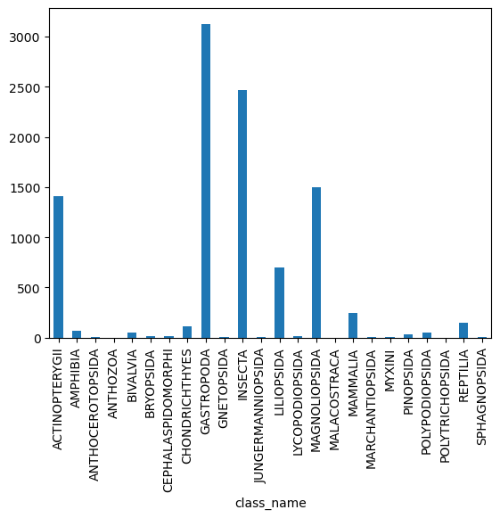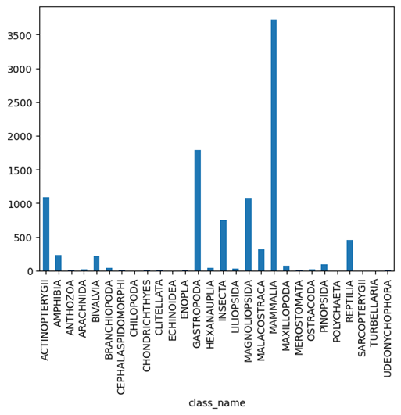

Another difference was found when comparing the frequencies of the different categories of assessment (Vulnerable, Extinct, Endangered, etc.) For both datasets most species were categorized as ‘Least Concern’, however the second largest group for the Global dataset was ‘Vulnerable’ whereas it was ‘Data Deficient’ for the European dataset. 

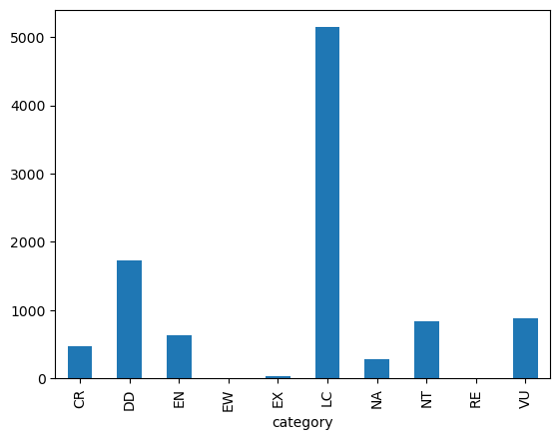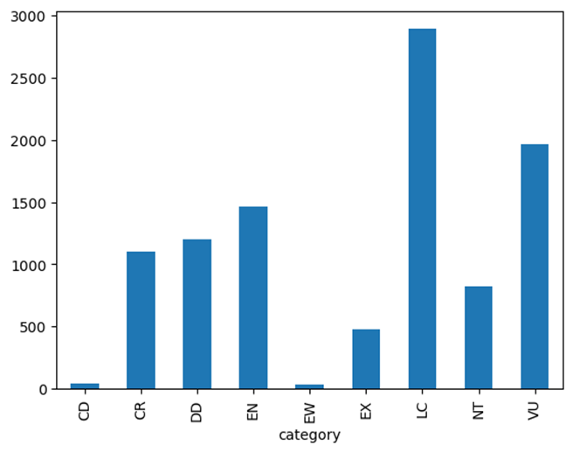

We next investigated the intersection of these trends, focusing on the Global dataset. In a comparison of the distribution of categories between Mammalia and Gastropoda, ‘Least Concern’ pops out as the vast majority of Mammalian species fall into it. By contrast Gastropoda tend towards either ‘Data Deficient’ or ‘Vulnerable' with relatively few species in ‘Least Concern’. Mammalian species are overrepresented in this dataset, and they tend to have robust populations. This makes sense from a logistics standpoint as Mammals tend to be larger bodied, and combined with large populations they would be low hanging fruit for assessment. The large number of Gastropoda that are in the ‘Data Deficient’ category may be related to their species tending to be in smaller population categories like ‘Vulnerable’.

Does Kingdom predict assessment categories?

We conducted a chi-squared test to look at the relationship of Kingdom and assessment category. Our null hypothesis was that Kingdom is independent of category. The hypothesis we were testing was that Kingdom is a predictor of an organism’s category. We tested this using our pseudo-random sample of the Global Assessment (n = 10,000).

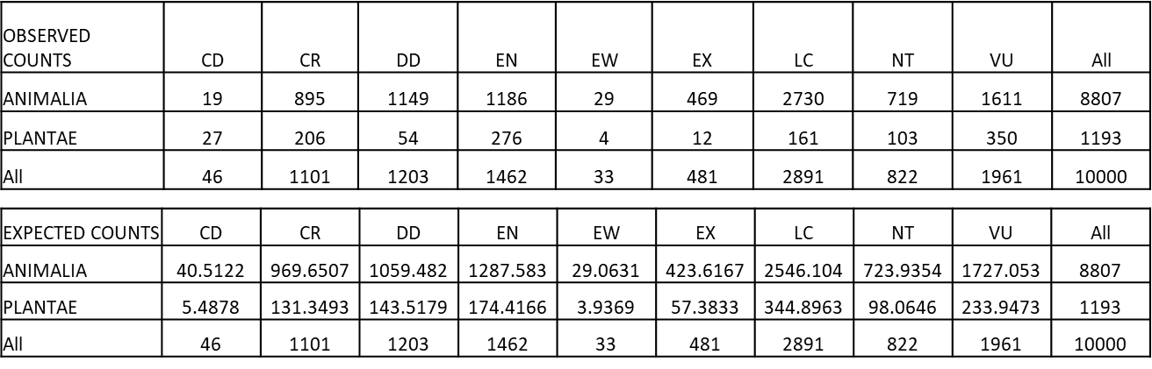

The chi-square statistic was 492.24 with 18 degrees of freedom which yielded a p-value of 4.45e-93. We therefore reject the null hypothesis of independence. Kingdom does appear to predict the frequency distribution of species into assessment categories. A further chi-square test testing the independence of Class and Category also yielded a statistically significant result (p-value = 0.0) leading us to reject the null hypothesis. Further analysis is needed to ascertain in what direction this impact occurs. Whatever findings this yields would be informative for where best to allocate resources for targeting species to assess.

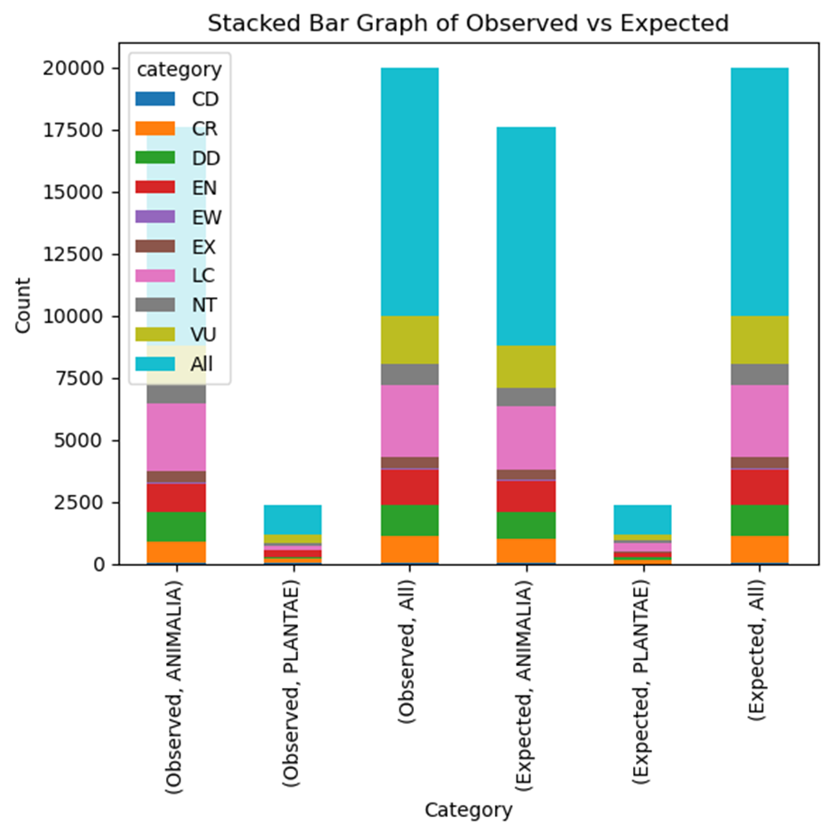

We wanted to analyze what are the highest threats to endangered species. Has their habitat been destroyed? Are humans responsible for the decline of most endangered species?

We use a data set sample for the Specie Loxodonta Africana, common name African bush elephant.

We created a plot bar using the top 10 threats to the African bush elephant. On this plot we can see that there are several threats to the survival of the African bush elephant, including:

* Hunting & trapping terrestrial animals: The tusks of African bush elephants are highly prized, and they are often used to make jewelry and other decorative items. Poaching is a major threat to the survival of the African bush elephant, and it is estimated that tens of thousands of elephants are killed each year for their ivory.
* Livestock farming & ranching: Their habitat is being lost and fragmented due to human activities such as agriculture, logging, and mining. This also increases their vulnerability to being hunted.
* Annual & perennial non-timber crops: Humans had been deforesting and change their habitat which is becoming increasingly fragmented, and their food sources are becoming more scarce.

The African bush elephant is a majestic and important creature. It is essential that we take steps to protect it from the threats it faces. We can do this by supporting anti-poaching efforts, reducing our demand for ivory, and protecting their habitat.

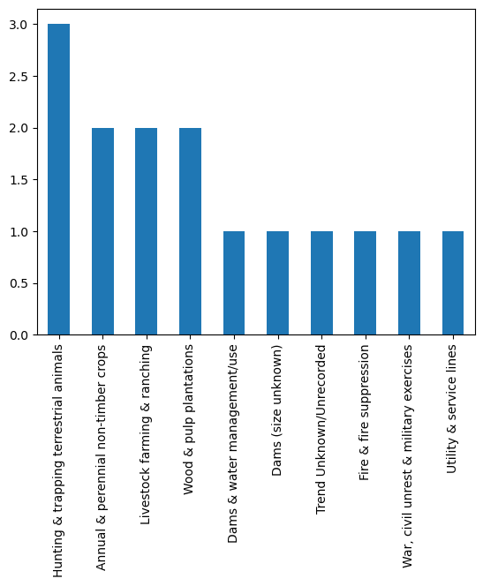

**Pufferfish**:

Hypothesis:

Null - There is no noticeable difference in the mean longitudinal distribution of the two genera of pufferfish

Alternative - There is a noticeable difference in the mean longitudinal distribution of the two genera of pufferfish

The Colomesus & Dichotomyctere genus of pufferfish live in different parts of the globe. The Colomesus in the southern hemisphere while the Dichotomyctere dwell in the northern hemisphere. Although the range of both fish is roughly 25 degrees, the mean distance from the r is vastly different. On average, the Colomesus are 59.59 degrees while the Dichotomyctere are 105.79 degrees from the. Both genus of fish have a relatively similar normal distribution with the Colomesus containing a few more outliers and a smaller IQR (under 10) with the Dichotomyctere coming in with a wider IQR (over 10). The null hypothesis is thus rejected as the mean longitudinal distribution is noticeably different in the two genera of pufferfish.